Isaac Ray Shoebottom

CS 1073 (FR02A)

Assignment 6

3429069

# Section A

## Source Code (LeapYearCheck.java):

/**

*This class takes a given date and tells the user if it is a leap year

* @author Isaac Shoebottom (3429069)

*/

public class LeapYearCheck {

public static void main(String[] args) {

java.util.Scanner scanner = new java.util.Scanner(System.in);

long year;

do {

System.out.print("Please enter a year: ");

year = scanner.nextLong();

if (year < 1582) {

System.out.println("Invalid Year, you cannot enter a year prior to 1582");

}

}

while (year < 1582);

if ((year % 4 == 0) && (year % 100 != 0) || (year % 400 == 0)) {

System.out.println("This is a leap year");

}

else {

System.out.println("This is not a leap year.");

}

}

}

# Section B

## Sample Output:

1.

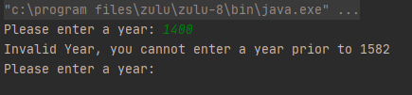2.

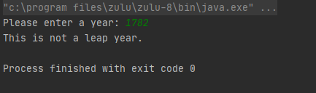

# Section C

## Source Code (MakingChange.java):

/**

* This class returns the amount of change the user would be given provided they give the amount they paid and the price of their items

* @author Isaac Shoebottom (3429069)

*/

public class MakingChange {

public static void main(String[] args){

java.util.Scanner scanner = new java.util.Scanner(System.in);

double totalPrice;

double amountPaid;

long changeTotal;

do {

do {

System.out.print("Please enter the total price: ");

totalPrice = scanner.nextDouble();

if (totalPrice <= 0) {

System.out.println("Invalid input. Please enter a positive number");

}

}

while (totalPrice <= 0);

do {

System.out.print("Please enter the amount paid: ");

amountPaid = scanner.nextDouble();

if (amountPaid <= 0) {

System.out.println("Invalid input. Please enter a positive number");

}

}

while (amountPaid < 0);

changeTotal = (long)(amountPaid*100) - (long)(totalPrice*100);

if (changeTotal< 0) {

System.out.println("Invalid inputs. The amount of change given must be at least zero \n");

}

}

while (changeTotal < 0);

long twenties = (changeTotal/2000);

changeTotal -= (twenties * 2000);

long tens = (changeTotal/1000);

changeTotal -= (tens * 1000);

long fives = (changeTotal/500);

changeTotal -= (fives * 500);

long toonies = (changeTotal/200);

changeTotal -= (toonies * 200);

long loonies = (changeTotal/100);

changeTotal -= (loonies * 100);

long quarters = (changeTotal/25);

changeTotal -= (quarters * 25);

long dimes = (changeTotal/10);

changeTotal -= (dimes * 10);

long nickels = (changeTotal/5);

changeTotal -= (nickels * 5);

long pennies = changeTotal;

System.out.println(

"\n" +

"Here is the change that they are due:\n" +

"20$ bills: " + twenties + "\n" +

"10$ bills: " + tens + "\n" +

"5$ bills: " + fives + "\n" +

"Toonies: " + toonies + "\n" +

"Loonies: " + loonies + "\n" +

"Quarters: " + quarters + "\n" +

"Dimes: " + dimes + "\n" +

"Nickels: " + nickels + "\n" +

"Pennies: " + pennies

);

}

}

# Section D

## Sample Output: